**How to Update the Documents into Collections?**

**db.COLLECTION_NAME.updateOne(<filter>, <update>):**

Update only first matched data in collection

**db.COLLECTION_NAME.update(<filter>, <update>):**

Update all matched data in collection

**Excercises:**

1. **Update firstly entered Haider name to Ali Status to false.** 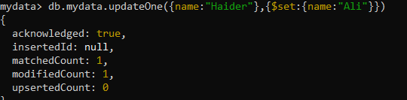 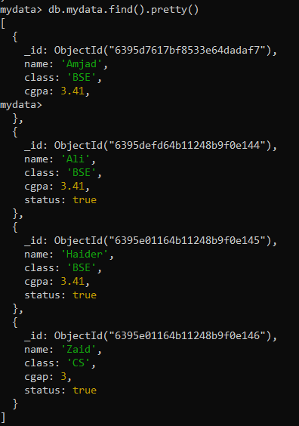
2. **Update all status to false who has class BSE.** 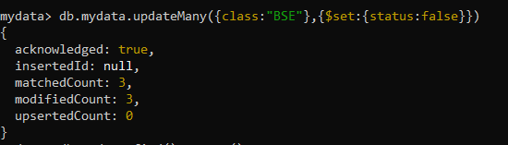 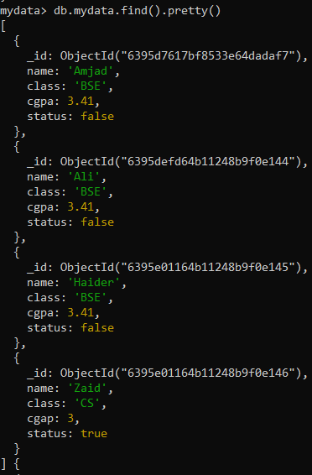
3. **Rename cgap to cgpa where name is Zaid.** 